cil_chi Tiz
Zoon Charitable Trust

Redg. 04-63-025

q q GI cel ,mmi Z

-9..apaGicipz WI' Tsim Umbri el4-11‘31

CticrtilUI t M-9. WEI 7-41° #I Willl

RIM Rzfrisaf 441; 4'414 ‘igiscrigi

I ZIT

31-44. talliVACh Chcrglui 41411U1111311:

W. G11.1c1 I

t9T 4i acri #r Uni <C%<Ctimi 4

ATIT min 1:r47
--<-4r# qi arcr4 4R ER

Aciii rum --<4 4 ari:pmf tz.4 4-i‘licki 3117 arra:03f7 w-44. 4 R-4-4

TIDacici Tiz t To Rft utqzr wiTs4chitg :-
CO Merr:

ZOON CHARITABLE TRUST

Right To Education

Trfta aft ciRcl AWI WI %f"-a. --rA-r, gr-A-qq. aft
RTilq ti6itici I 117479. Wr4T1 aft 41rut.itALTql T

ITI:47 WrAT.
(2) Rzir-oxim Tiar:

RRict-ii TA-M.9.0 174-R ter, 414iiPtil tl. v1-21-rri
--<-4.r, ailz wirpir tti-iIGfter mil4Itimch Wr4T I

(3) 4'414 %le-Attie-I:

mi‹m<ci4-i4 Firri air4RT aft? air %'1:47:1Te
‹c%<cl_a 41 arrvfa WiRTI Assi arfliftebl •
Trr? fa7 cbiffoil
(4) tiiivAch chcrimui:

•Rci
an-rtri
(5) 4Z1 4<u1

-11;aNi
iFr• k;,/

wiRTI aft? AETZ *Tr.

Environmental. Protection

WM' ch‹•-i if 444
c111141 IF 34 eel ul WIT Wr4T1 aft cim-tiacil 74.TT
4) <Nil

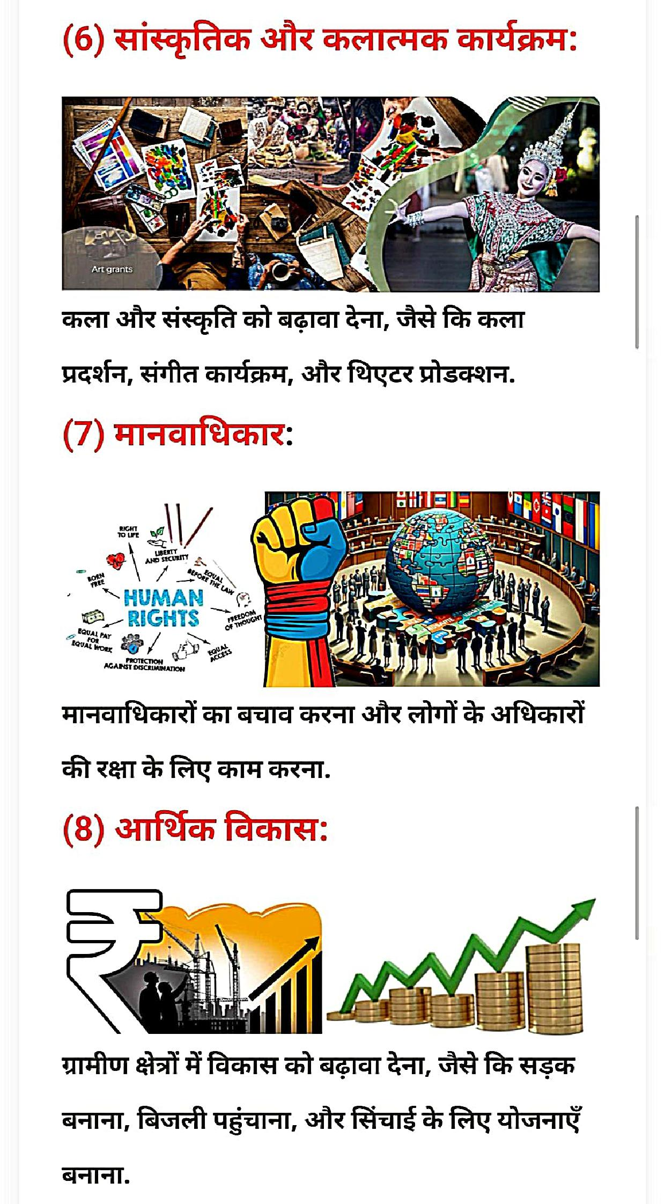

(9) tillilDch

aRTITR-dT W-Avt M7 WM WZ-41;
ft ft %AIM, vrtzfT fATr autrm ER aura al.

WM' ter.
(1 0) ZITITTRWrjk *1514d_1:

illi ea

agiS Ell ER G

II 'MI

1( Ckyi
70:

16T

0
r Pi
IA
Wei

i.

•-!...41 i
arrEmrailm arm aiitild f Mti1111'
cfrolir *4' it Wmgygitrill 3117 (1 1 ) iiPi1Pch AWE

ch chceq ui MR' WIT Wr41.r ATI ft ti 4.4
3d-4-Lim; *ci-cocti art-44 Ili; 3117 '<Mg 1 ftfaZO

mitx?4 1* 1.' ' L'' 'ii.J'tt3.1 4ie Itib>q) 0104 ie
im.ftraLEte iii-,›Lb 01-04 e_.:tukR,_%1 Kc% iii-9*
itt3Pt>ter hei T. t>tt3 '?'?J' te l' 'ID '?i-tp>%'m-r%•.

A
attt q'ele (E L) w-okmvi trlq to
N I% I 1•514 WIbig, _T:1 te'N, i I 1-■>442 421,24ile I Is% .2...4.Ittli.

lailb I 443 inik 1■11711 J PhOI4 (1-61■1443 .p. Mite kelt

:1PI71 14 tialaltb (Z I,)

(14) Plitr al17 luct)iitie.

TiTrnif chtrti lin t 1.- • Ow ch<ii 311V

7I t,Er aTtrigi <ivici5v AtTiLfirf *iRci egeiciyi
IWIIAI, 44)Zr t-iTril 1:13Tre 1i1644iet ti 1115h q.-471 lt,ukftEr wrziwAnfi a19-444 61<iciicwiErgaltl

NM 419 GiiIMIN MEI
OM NMMEM
ZOON CHARITABLE TRIM
NATIONAL OFFICE taanchataabletrusta genani cam

7TEFtEr alwriar ltr7TECtEr tiRci vcriy1

qc t-irts Mat 44164-94 dash W-47

411171itri ctlicichiPun gkcellci
41;741.4 urrrwrei. f4g. Q. i

Our Dream
Whole Universe

CHA₹ITABL€ TRUST

64-im TFRT Ifitlichiq4UTITT *vim

VIITT I alTrW' 6ii ilT21 W-4T Ta I
arrqTriftwu-4:rami

